Initiation Plan / GEF PPG

Project Title: Enhancing Namibia’s capacity to establish a comprehensive Transparency Framework for Monitoring, Reporting and Verification (MRV) of climate actions and reporting on NDC implementation under the Paris Agreement

Country: Namibia

Country Programme Outcome: By 2023, vulnerable populations in disaster-prone and biodiversity-sensitive areas are resilient to shocks and climate change effects (and benefit from natural resource management) Output 2.2: Scaled up integrated and innovative action on climate change adaptation and mitigation across priority sectors which is funded and implemented

RELATED STRATEGIC PLAN OUTCOME: Outcome 3: Build resilience to shocks and crises. UNDP Strategic Plan Output: Under Signature Solution 3 (Enhance national prevention and recovery capacities for resilient societies), Outputs: 3.3.1. Evidence-based assessment and planning tools and mechanisms applied to enable implementation of gender-sensitive and risk-informed prevention and preparedness to limit the impact of natural hazards and pandemics and promote peaceful, just and inclusive societies, and 3.3.2. Gender-responsive and risk-informed mechanisms supported to build consensus, improve social dialogue and promote peaceful, just and inclusive societies.

Gender Marker rating: GEN 2
SESP Pre-Screening Categorization: Exempted
ATLAS Project ID: 00121666  ATLAS Output ID: 00117598  PIMS ID: 6337  Management Arrangement: DIM | Total GEF budget:  Allocated resources:  - GEF  - Government  - UNDP | US$50,000  US$50,000  US$ 0  US$ 0

Agreed by

 |  | Day/Month/Year
Ms. Alka Bhatia, UNDP Resident Representative | Signature | Date

Table of Contents
I. Brief Description of the Initiation Plan/GEF PPG 4
1.1: Institutional arrangements for a national transparency (MRV) framework are in place 4
2.1: Enhancement of greenhouse gas inventories as per gaps and needs previously identified 4
2.2: Building MRV capacities of support 4
3.1: Progress tracking tool on NDC and transparency in place 4
The following information is to be consulted as background for the GEF PPG phase: 4
II. Stakeholder Engagement, public disclosure and other requirements 6
III. GEF PPG Activities 6
Component A: Preparatory Technical Studies & Reviews 6
Component B: Formulation of the UNDP-GEF Project Document, CEO Endorsement Request, and Mandatory and Project Specific Annexes 9
Component C: Validation Workshop and Report 11
IV. Total Budget and Work Plan for GEF PPG 11
V. GEF PPG Activities timeframe and budget 13
VI. Mandatory Annexes 14
Annex 1: GEF CEO PIF/PPG Approval Letter 14
15
Annex 2: Draft Terms of Reference (TORs) of Consultants Financed by the Project Preparatory Grant (GEF PPG) 16

Brief Description of the Initiation Plan/GEF PPG

Objective & Final Outputs
This Initiation Plan (IP) describes how the GEF Project Preparation Grant (PPG) will be used to develop a full Project Document (Prodoc), and supporting materials, for the project: “Enhancing Namibia’s capacity to establish a comprehensive Transparency Framework for Monitoring, Reporting and Verification (MRV) of climate actions and reporting on NDC implementation under the Paris Agreement”. The Project Concept Note (PIF), which was submitted by the Government of Namibia, with support of UNDP as the GEF Agency, forms part of a package of child projects included in the Programme Framework Document (PFD) that was submitted to the July 2019 GEF Council for consideration through the United Nations Development Programme (UNDP).

In brief, this project, referred to as Capacity Building Initiative for Transparency (CBIT) has an overall objective to enhance Namibia’s institutional and technical capacities to establish a comprehensive Transparency Framework for Monitoring, Reporting and Verification (MRV) of climate actions and to report on NDC implementation under the Paris Agreement. In the absence of MRV framework, the methodologies and tools to enhance transparency as stipulated in Article 13 of the PA will not be met. In addition, Namibia will not be able to put in place an MRV system that will smoothen and facilitate provision of accurate information, monitoring and assessment of the instruments that the country selects to address climate change. Furthermore, Namibia will not be able to increase ambitions under its NDCs, as there is a major need to improve its institutional capacities and establish sustainable Institutional Arrangements. Thus, the project provides an alternative approach that is structured around three main components, which have related outcomes and a number of outputs designed to realize the objective of the project. Altogether these three components will enhance capacities to meet the provisions stipulated in Article 13 of the Paris Agreement. During the PPG phase, gender-sensitive approaches will be fully considered to fully meet the CBIT guidelines. Moreover, Namibia will share the progress and achievements in establishing the transparency framework with other countries following the CBIT global coordination platform as well as the GSP.

The three components are: 1) Enhancing and strengthening Namibia’s institutional arrangements for robust GHG inventories and Transparency MRV System/Framework for climate actions and NDC; 2) Provision of tools, training and assistance for meeting the transparency provisions established in the Paris Agreement; and 3) NDC tracking. Specific outcomes to be derived from the three components are:

1.1: Institutional arrangements for a national transparency (MRV) framework are in place

2.1: Enhancement of greenhouse gas inventories as per gaps and needs previously identified

2.2: Building MRV capacities of support

3.1: Progress tracking tool on NDC and transparency in place

The following information is to be consulted as background for the GEF PPG phase:
- GEF Approved CBIT PIF
- GEF CEO Approval letter
- Comments from GEF Secretariat, Council, STAP
- Annotated UNDP-GEF Project Document Template and associated guidance included therein
- UNDP policies and procedures
- GEF policies

The final outputs of the GEF PPG are:
- UNDP-GEF Project Document (ProDoc), completed using the relevant template.
- Mandatory annexes to the ProDoc, listed in the Annotated UNDP-GEF Project Document Template.
- GEF CEO Endorsement Request.
- Validation Workshop Report (required for all projects with a high SESP categorization).
Any additional studies and other reports produced under the GEF PPG and not included in the Annexes to the project document will be submitted to UNDP and saved for future reference.

Key Dates for the GEF PPG

Milestone | Date | Notes
Internal submission date for UNDP-GEF review and clearance | February 8, 2020 | 10 months of PIF approval for FSPs and 6 months for MSPs.
First GEF Submission Deadline for CEO Endorsement | March 27, 2020 | First submission must be within 12 months of PIF approval for FSPs and 8 months for MSPs. Failure to submit a ProDoc and CEO ER to the GEF Sec by this date will lead to the automatic cancellation of the project by the GEF Sec.
CEO Endorsement Deadline after which the project will be cancelled if not endorsed. | August 8, 2020 | Endorsement must be within 18 months of PIF approval for FSPs and 12 months for MSPs. If the project has not been CEO endorsed by this date, then it will be automatically cancelled by the GEF Sec.

Management Arrangements
The UNDP Namibia Country Office will lead the project development process and manage the GEF PPG budget in full consultation with the UNDP-GEF Technical Adviser. The GEF PPG Atlas budget is presented in Section IV: Total Budget and Work Plan.

As appropriate, a Working Group will guide the GEF PPG team, and review and endorse the GEF PPG deliverables. The Working Group will be responsible for ensuring that the deliverables outlined in this GEF PPG are completed on time and in line with UNDP and GEF requirements. The Division of Multilateral Environmental Agreement (DMEA) of the Ministry of Environment and Tourism (MET) will chair the Working Group. Working Group members will include: the National Planning Commission (NPC), the Namibian Statistics Agency (NSA), a representative from the Namibia NDC Partnership Platform, selected technical experts from the Namibian Climate Change Committee (NCCC), key expert working group members from the BUR and NC Projects, the EU, UNDP. The Working Group can call upon the Ministry of Agriculture, Water and Forestry (MAWF), Ministry of Mines and Energy (MME), Ministry of Industrialization, Trade and SME Development (MITSD) and other relevant stakeholders on a need basis.

The GEF PPG team will be composed of the following staff complement, whose Terms of Reference (TOR) are described in Annex 2:

- Project Development Specialist, with specialization in environmental management (Team Leader), and
- Gender and Stakeholder Engagement Specialist

As PPG team members, these two will be supported by the MET, NSA, NDC Partnership, and UNDP. which will be working closely with the DMEA CC Unit of the MET to do the archiving. The CC Unit together with the international consultant will also provide support towards capacity building, IPCC process and COP decisions. The GHG Inventory Coordinator will seek to bring together the leading ministries for the following sectors: Energy (MME), IPPU (MITSD), AFOLU (MAWF), and Waste (MET). Data will be provided by NSA and other stakeholders, while research institutions and universities will contribute towards emission factor improvement.

Stakeholder Engagement, public disclosure and other requirements

To ensure strong country ownership, and in line with the stakeholder engagement requirements outlined in UNDP’s Social and Environmental Standards (SES), the SES Guidance Note of Stakeholder Engagement, the GEF’s Guidelines on the Implementation of the Policy on Stakeholder Engagement and the GEF Policy on Gender Equality, the development of the project to be undertaken during this GEF PPG phase will be done in full consultation and close engagement with government, CSOs and all other relevant stakeholders – in particular those who will benefit from and be directly involved in the implementation of the project (i.e. direct project beneficiaries) and those who may be impacted (positively or negatively) by the project. Stakeholder Engagement and analysis must be conducted in an inclusive and gender-responsive manner, so that the rights of women and men and the different structural barriers, knowledge, needs, roles and interests of women and men are recognized and addressed.

Careful and complete documentation of stakeholder engagement is vital. Detailed evidence of all consultations must be prepared and submitted to UNDP. A list of the consulted stakeholders and details of the associated meetings will be included in an Annex to the project document, in addition to the Stakeholder Engagement Plan (see section B-d below).

If the fully designed project has an overall Social and Environment Screening Procedure (SESP) categorization of moderate or high, then the following disclosure requirements apply:

- A final validation workshop report will be prepared summarizing the outcomes of the validation workshop and other consultations undertaken during the PPG phase. This report will become a key reference document should an environmental and social complaint/grievance be filed during project implementation. This is mandatory for high risk projects and recommended for moderate risk projects.
- The UNDP-GEF project document, SESP and related draft management plans, and other relevant information/documents, will be made available to the public on the UNDP Country Office website or open.undp.org. It is recommended to make these documents available for 30 days in advance of the LPAC meeting for moderate risk projects, and 120 days in advance for high risk projects.

See the SES Supplemental Guidance on Disclosure for more information.

GEF PPG Activities

Component A: Preparatory Technical Studies & Reviews
The following technical studies and reviews will be conducted.

Desktop and field-based studies and data collection
This research should produce the background information required to prepare the ProDoc (including its Annexes) and CEO Endorsement Request, including but not limited to:
- Development challenge and strategy (including threats, problems and barrier assessment);
- Review of national policy and legislative frameworks;
- Problem and solution trees developed in consultation with project stakeholders, for a robust Theory of Change, Results Framework and solid M&E plan;
- Review of relevant past and ongoing projects for lessons, including project evaluations; and
- Any other analyses required to address all comments on the PIF received from GEF Secretariat, GEF Council members and STAP.

In particular, the following must be addressed:

Working in close co-operation with officials in the Ministry of Environment and Tourism, the Namibian Statistical Agency (NSA), National Planning Commission, and other relevant stakeholders, and drawing on all available policies, reports and guidelines, conducting desk-top assessments, consultations and field research (where necessary) to obtain relevant information required for the implementation of the 3 project components.

Project Component 1: Enhancing and strengthening Namibia’s institutional arrangements for robust GHG inventories and transparency MRV System/framework for climate actions and NDC

Under this component, the following will be considered as key.

- Ensuring that institutional arrangements for a national transparency (MRV) framework are in place, which will be made possible through:

  - Strengthening the working groups in each of the 4 key sectors (Energy, IPPU, AFOLU and Waste) and ensuring that they are functioning as key entities for data collection and processing;
  - Drafting and adopting legal and/or regulatory requirements for a national transparency framework;
  - Establishing an integrated MRV system (hardware and software) of tracking tools for transparency-related actions and progress;
  - Mainstreaming of gender issues into transparency activities; and
  - Sharing lessons learned at the regional and global levels through the CBIT Global Coordination Platform.

Project Component 2: Provision of tools, training and assistance for meeting the transparency provisions established in the Paris Agreement

This component will seek to carry out the following activities:

- Enhancement of greenhouse gas inventories as per previously identified gaps and needs, anticipated to be achieved through:

  - Development and implementation of a quality control management system, including enhanced documentation management;
  - Enhancing activity data in key sectors, as per findings identified in the GSP-UNFCCC QA exercise held in July 2018, giving priority in particular to improving data from medical waste and medical applications, country specific factors in livestock and improved data in AFOLU; and
  - Training of relevant entities on GHG inventories and on the use of the IPCC 2006 guidelines and its software.

- Building MRV capacities of support. This will be made possible through:

  - Development of guidelines and data collection templates to track support, and in light of existing experiences under CBIT;
  - Provision of training to relevant stakeholders from the public and private sector to facilitate the implementation of the enhanced transparency framework and its components; and
  - Integration of data regarding support received and provided, into future NCs and BURs.

Project Component 3: NDC tracking

Ensuring the success for the implementation of this component will require:

- Putting in place a progress tracking tool on NDC and transparency. This will be made possible through:

  - Review of information provided in the NDC, including quality review of baseline projections; and
  - Development and implementation of a methodology to keep track of progress in the implementation of NDCs and transparency.

Gender Analysis
A gender analysis will be prepared to fully consider the different needs, roles, benefits, impacts, risks, differential access to and control over resources of women and men (including considerations of intersecting categories of identity such as age, social status, ethnicity, marital status, etc.) and to identify appropriate measures to address these and promote gender equality and women’s empowerment. See guidance available here.

Social and Environmental Standards: Screening and Assessments
In line with the risk-based exemption criteria, this project is exempt from the SESP requirement, and therefore the SESP screening is not required. The project is exempted on the basis that it is an enabling activity that falls in the two selected criteria below. Criteria for exempt from SESP:
• Preparation and dissemination of reports, documents and communication materials
• Organization of an event, workshop, training
• Strengthening capacities of partners to participate in international negotiations and conferences
• Partnership coordination (including UN coordination) and management of networks
• Global/regional projects with no country level activities (e.g. knowledge management, inter-governmental processes)
• UNDP acting as Administrative Agent

Identification of project sites
This project is to be executed at the national level; thus, by default targets all 14 regions of Namibia. However, where necessary and/or based on the PPG process, particular focus may focus on the regions with high GHG emissions, and those hardest hit by the climate change impacts, mainly droughts and floods. It is not expected that this project will have pilot/demonstration sites.

Financial planning
Co-financing indicated in the PIF will be confirmed and additional sources to be identified through a series of consultations with partners (e.g. EU< GIZ, NPC, NSA, MET, etc.) during the PPG phase. This will ensure a coherent and sustainable financing package for the project, including post-GEF grant phase to the extent possible.

Stakeholder analysis
Building on the initial identification of stakeholders in the PIF, an appropriately-scaled analysis of project stakeholders will be undertaken. This stakeholder analysis will provide the foundation for development of the project’s comprehensive Stakeholder Engagement Plan and will facilitate prioritization of engagement activities with particular stakeholder groups and individuals. See the UNDP SES Guidance Note on Stakeholder Engagement.

The Comprehensive Stakeholder Engagement Plan must be appended as an Annex to the Prodoc.

Other required studies
During inception, the CC Unit will identify additional studies that may be required to be carried out during the PPG phase. These should be approved by the Working Group that will oversee the PPG.

Component B: Formulation of the UNDP-GEF Project Document, CEO Endorsement Request, and Mandatory and Project Specific Annexes

Based on the technical studies and reviews undertaken under Component A, the UNDP-GEF Project Document will be developed (following the annotated UNDP-GEF Project Document available here), and the GEF CEO Endorsement Request (available here) will be prepared. See additional guidance notes below.

The GEF PPG Team Leader will be responsible for the consolidation and finalization of all required materials.

Stakeholder Engagement Plan:
At a minimum, the Plan must include the following elements:
- Stakeholders who have been and will be engaged (based on stakeholder analysis), including potentially marginalized or disadvantaged groups/individuals (the ‘who’)
- Key stakeholder objectives and interests (the ‘why’)
- Steps and actions to achieve meaningful consultation and inclusive participation, including information dissemination and any special measures required to ensure inclusive participation of marginalized disadvantaged groups/individuals the dissemination of information (the ‘how’)
- Breadth and depth of stakeholder engagement throughout the project cycle, and decisions that need to be made through stakeholder engagement (the ‘what’)
- Timeline for engagement activities and how they will be sequenced, including information disclosure (the ‘when’)
- Indicators of stakeholder engagement and monitoring plan
- Roles and responsibilities for ensuring effective stakeholder engagement through implementation of the Plan
- Resource requirements and associated budget for implementation of the stakeholder engagement plan.

For fully designed projects with a SESP rating of Moderate and High:
- A project-level Grievance Redress Mechanism (GRM) must be described in the comprehensive Stakeholder Engagement Plan and established in the first year of project implementation. See the UNDP guidance on GRM and sample TOR.
- A comprehensive Stakeholder Engagement Plan is required.

See the UNDP SES guidance on Stakeholder Engagement, the standard SEP template, and the GEF guidelines on stakeholder engagement.

Gender Action Plan
The gender analysis, along with relevant findings from the stakeholder analysis and background studies, will form the basis of a Gender Action Plan to guide gender mainstreaming during project implementation. The Gender Action Plan must include indicators, targets, timeframe, responsible party and budget which are linked to the project’s components/outputs, outcomes and activities. As part of the work of preparing the Gender Action Plan, indicators should be proposed for inclusion in the Results Framework to facilitate the monitoring of the proposed gender mainstreaming actions.

See guidance available here.

Social and Environmental Standards: Screening and Management Measures
In line with the assessments conducted during Component A (above) and UNDP’s Social and Environmental Standards (SES) policy and all associated SES Guidance Notes, the SESP will be updated and all risks identified in the SESP will be reflected in the risk table and risk section of the ProDoc.

No management plans are required.

See the SES Guidance Note on Assessment and Management for further guidance. Please contact UNDP for additional information as needed.

GEF and LDCF/SCCF Core Indicators
The CEO endorsement-stage data for the relevant Core Indicators and sub-indicators will be prepared.
The completed Core Indicators worksheet—with both the original PIF-stage data and the CEO endorsement-stage data—will be annexed to the ProDoc. The Core Indicators will be used in the project’s Results Framework, at the Objective level, where appropriate. See the GEF policy and guidance.

Other mandatory tracking tools will include:
- The GEF-& Management Effectiveness Tracking Tool: As part of the GEF Core Indicators requirement, the required METTs will be prepared in the GEF-7 Excel template; the relevant details will be included in the Core Indicators template; and the final Excel METT file will be submitted to UNDP (but will not be annexed to the ProDoc).

- The GEF-7 GWP Tracking Tool (provided by the World Bank), if required – to be confirmed at inception.

Completion of the required official endorsement letters
These letters include the official letters on co-financing guarantee(s) from participating government institutions, bilateral development partners, multilateral development partners, NGOs, private sector, or others who wish to provide cash or in-kind contributions to the project.

Updated GEF OFP endorsements letters are also required if the requested GEF grant amount has changed since PIF/PFD approval.

Mandatory Annexes:
In addition to the documents listed above, the following Annexes should be prepared by the GEF PPG team: Initial Project Team Procurement Plan and TORs for key Project Team staff; List of people consulted during project development

Component C: Validation Workshop and Report
A validation workshop will be held with relevant stakeholders to present, discuss and validate the project activities, and the final draft of the UNDP-GEF project document if possible. A validation workshop report must be prepared for projects with an overall safeguards risk rating of moderate or high.

Total Budget and Work Plan for GEF PPG

Award ID: | 00121666
Award Title: | 00117598
Business Unit: | NAM10
Project Title: | Enhancing Namibia’s capacity to establish a comprehensive Transparency Framework for Monitoring, Reporting and Verification (MRV) of climate actions and reporting on NDC implementation under the Paris Agreement
Project (PIMS) ID: | 6337
Implementing Partner: | UNDP

GEF Outcome/Atlas Activity | Responsible Party | Fund ID | Donor Name | Atlas Budgetary Account Code | ATLAS Budget Description | Amount US$ | Budget Notes
Project preparation grant to finalize the UNDP-GEF project document for project titled: “Enhancing Namibia’s capacity to establish a comprehensive Transparency Framework for Monitoring, Reporting and Verification (MRV) of climate actions and reporting on NDC implementation under the Paris Agreement” | UNDP | 62000 | GEF TRUSTEE | 71200 | International Consultants | 24,500 | A
 |  |  |  | 71300 | Local Consultants | 12,500 | B
 |  |  |  | 71600 | Travel | 3,000 | C
 |  |  |  | 72500 | Supplies | 2,000 | D
 |  |  |  | 74500 | Miscellaneous | 2,000 | E
 |  |  |  | 75700 | Training | 6,000 | F
 |  |  |  |  | PROJECT TOTAL | 50,000

Budget Note | Items | Total estimated person weeks | Budget | Budget Note
A | Project Development Specialist (Team Leader) | 7 | US$24,500.00 | Please see Annex 2 for key responsibilities of consultants.
B | Gender and Stakeholder Engagement Specialist | 5 | US$12,500.00
C | Travel |  | US$3,000.00 | Provision for travelling costs and per diems for consultants (nationally and internationally)missions
D | Supplies |  | US$2,000.00 | Stationery, workshop materials, advertising materials etc.
E | Miscellaneous |  | US$2,000.00 | To cover costs related to ICT, in case the venues being used do not have these and communication materials for advocacy purposes and planning meetings
F | Workshop |  | US$6,000.00 | Inception and validation workshops

GEF PPG Activities timeframe and budget
This section is optional
PPG Activity | Month  1 | Month  2 | Month  3 | Month  4 | Month  5 | Month  6 | Month  7 | Month  8 | Month  9 | Month  10 | Budget (US$)
Component A: Technical studies, etc. | X | X | X | X
SESP (to be submitted for approval) |  |  |  |  | X
Component B: Formulation of ProDoc, etc. |  |  |  |  | X | X | X
Component C: Validation Workshop |  |  |  |  |  |  |  | X
Review and refinement of outputs and preparation for submission |  |  |  |  |  |  |  | X | X
Delivery of final outputs |  |  |  |  |  |  |  |  |  | X

Mandatory Annexes

Annex 1: GEF CEO PIF/PPG Approval Letter
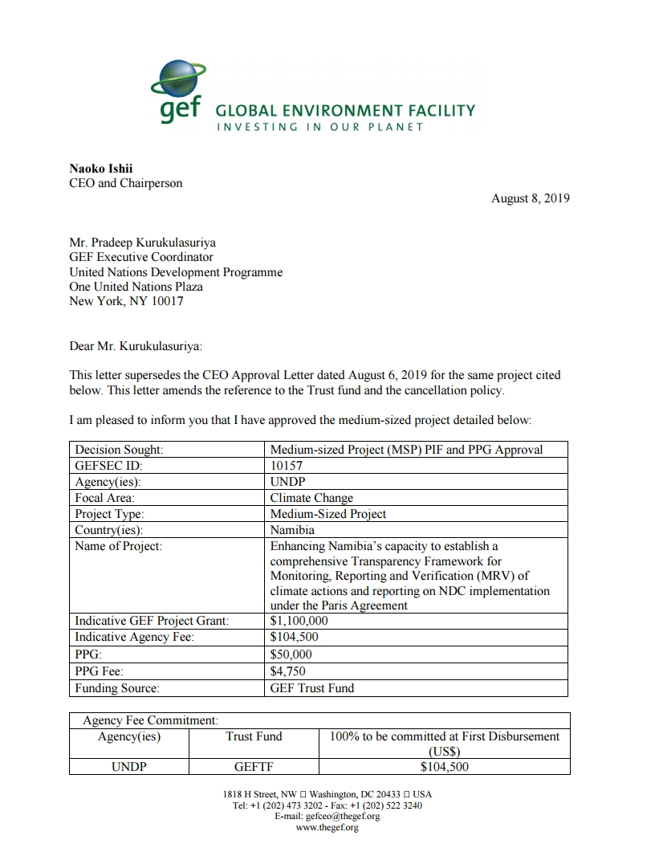

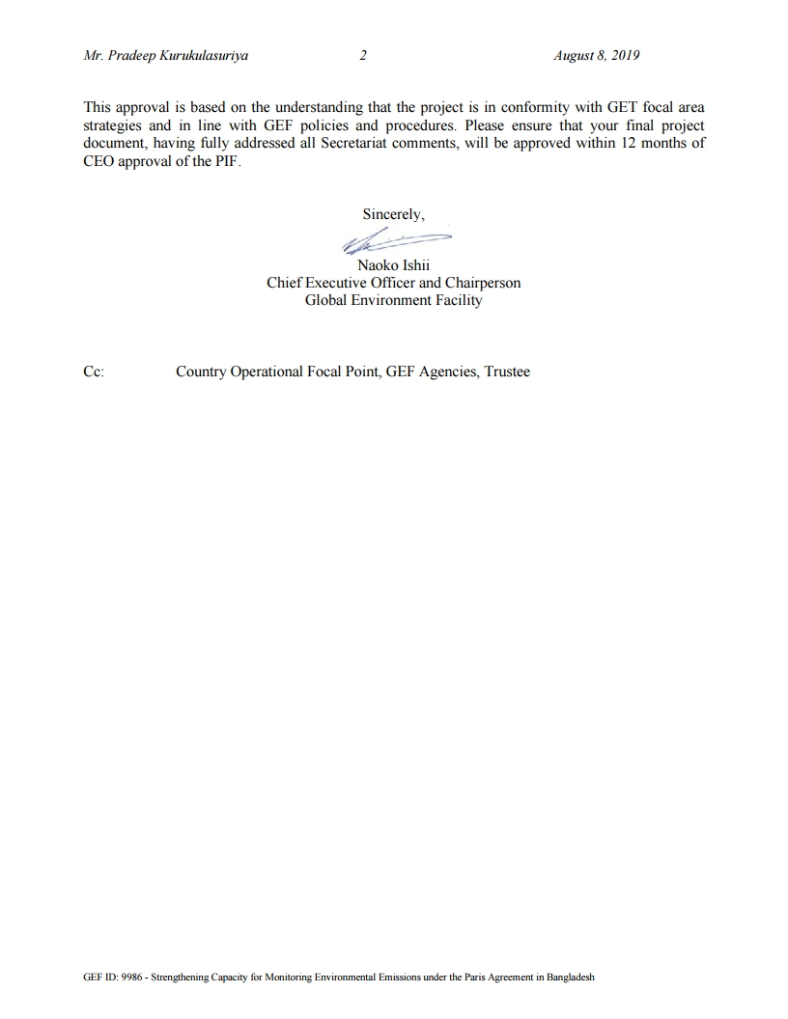

Annex 2: Draft Terms of Reference (TORs) of Consultants Financed by the Project Preparatory Grant (GEF PPG)

Position, Type and Cost | Role, Deliverables and Qualifications
Position: Project Development Specialist (Team Leader)  Type: International Consultant  Cost per person per week: US$3,500.00  Number of person 7 weeks  Total = US$24,500 | Role  The Project Development Specialist (PDS) will be the GEF PPG Team Leader and will be responsible for quality assurance and timely preparation of all reports and documentation, including the finalized UNDP Project Document (ProDoc) and CEO Endorsement Request, with all mandatory and project specific Annexes and supporting documentation. S/he will be responsible for managing all consultants on the GEF PPG Team, and coordinating the Team’s work.  The PDS will have the overall responsibility to manage all aspects of project preparation activities, including gathering of necessary information, ensuring involvement of all relevant sectors, holding workshops, and report writing. The general work to be done by the PDS will be expected to make a significant contribution towards the establishment of the Monitoring, Reporting, and Verification (MRV) system for climate actions in Namibia. In essence, the PDS should have a general understanding of all the GHG sectors, a valuable understanding of the UNFCCC national GHG Inventory reporting guidelines, a comprehensive understanding of the Nationally Determined Contributions (NDCs) under the Paris Agreement, and a sound understanding of the IPCC guidelines for national GHG Inventories. He/she should be able to work independently, and with a wide range of stakeholders (government institutions, research institutions, UN agencies, research agencies etc.).  The main responsibilities for the PDS will mainly be, but not limited to the following:  - Coordinating the day-to-day activities of the Project Preparation Grant (PPG) for the CBIT Namibia Project (including work planning, project implementation, coordinating the team and delegating tasks as necessary);  - Ensuring relevant information around the establishment of a comprehensive Transparency Framework for Monitoring, Reporting and Verification (MRV) of climate actions and to report on NDC implementation under the Paris Agreement is gathered;  - Identification of all relevant stakeholders;  - Ensuring involvement of all relevant sectors, and identifying and overseeing national inventory sector leads (providing assistance with the preparation of work plans, data collection and compilation, data organization for inclusion in the inventory, and assigning responsibilities as necessary);  - Quality assurance;  - Organising meetings and workshops (including the validation workshop) as necessary;  - Establishing relationships with related national projects, and other regional, international programmes where necessary;  - Development of consultants contracts to for consultancies aiming support updating the inventory and compiling reports;  - Reporting progress to the MET and UNDP.  - Development of the Project Document for the Medium-Size Project; and  - Submitting the CEO endorsement request.  Deliverables  - Management of the GEF PPG Team  - Define and submit a detailed methodology and work plan in consultation with the other consultants with clear delegation of responsibilities for the International Consultants (ICs) and National Consultants (NCs);  - Ensure that project development is participatory, gender-responsive and based on extensive stakeholder engagements; and  - Verify and ensure that all project components are technically sound and cost effective.  - Preparatory Technical Studies and Reviews (Component A): With inputs from the other national and international consultants, as detailed in their respective TORs:  - Compile baseline/situational analysis for the medium-size project (MSP). This will include a precise definition of baseline projects, activities, budgets, goals and co-financial links to GEF outcomes; definition of GEF incremental value per outcome and output; and presentation of results of the incremental cost-analysis in matrices as appropriate;  - Oversee the stakeholder analysis and consultations and ensure that they are complete and comprehensive;  - Ensure the preparation of the gender analysis and ensure its findings are meaningfully integrated into the project’s strategy, theory of change and results framework;  - Ensure action points, including risk assessments, from the UNDP Social and Environmental Screening Procedure (SESP) at the PIF stage (“pre-screening”) are fully implemented during the PPG, and update that screening in an iterative fashion throughout the PPG, as appropriate;  - Conduct/oversee the identification of the project sites, with documentation of selection criteria;  - Oversee the consultations with partners regarding financial planning; and  - Ensure completion of any additional studies that are determined to be needed for the preparation of the ProDoc and all other final outputs.  - Formulation of the ProDoc, CEO Endorsement Request and Mandatory and Project Specific Annexes (Component B): With inputs from the other national and international consultants, as detailed in their respective TORs, and based on international best practice:  - Develop, present and articulate the project’s theory of change;  - Develop the Results Framework in line with UNDP-GEF policy;  - Develop a detailed Monitoring and Evaluation Plan and Budget;  - Oversee and ensure the preparation of a Stakeholder Engagement Plan;  - Oversee and ensure the preparation of a Gender Action Plan and Budget;  - Update the SESP based on assessments undertaken during Component A, and ensure the development of required environmental and/or social management plan(s);  - Prepare the required GEF Core Indicators;  - Secure and present agreements on project management arrangements;  - Ensure the completion of the required official endorsement letters; and  - Synthesize all analyses, studies, etc. that are prepared under Components A and B to produce the draft UNDP-GEF ProDoc, GEF CEO Endorsement, and all mandatory and project specific Annexes, using the required templates.  - Validation Workshop (Component C):  - Lead the validation workshop to present, discuss and validate the final draft ProDoc and mandatory and project specific annexes, with a special focus on the SESP and any management plans; and  - Oversee all necessary revisions that arise during the workshop.  - Ensure completion of Validation Workshop Report.  - Final Deliverables:  - Consolidation of all technical and consultation inputs including from national stakeholders, UNDP, GEF Secretariat, STAP and GEF Council, into a well written and concise UNDP ProDoc with all required sections and Annexes, in line with the standard UNDP-GEF ProDoc template and annotated guidance;  - Completion of the GEF CEO Endorsement Request;  - All documentation from GEF PPG (including technical reports, etc.); and  - Validation Workshop Report.  - Synthesize all analyses, studies, etc. that are prepared under Components A and B to produce the draft UNDP-GEF ProDoc, GEF CEO Endorsement, and all mandatory and project specific Annexes, using the required templates.  Validation Workshop (Component C):  - Lead the validation workshop to present, discuss and validate the final draft ProDoc and mandatory and project specific annexes, with a special focus on the SESP and any management plans; and  - Oversee all necessary revisions that arise during the workshop.  - Ensure completion of Validation Workshop Report.  Final Deliverables:  - Consolidation of all technical and consultation inputs including from national stakeholders, UNDP, GEF Secretariat, STAP and GEF Council, into a well written and concise UNDP ProDoc with all required sections and Annexes, in line with the standard UNDP-GEF ProDoc template and annotated guidance and as approved by the UNDP-GEF RTA  - Completion of the GEF CEO Endorsement Request  - All documentation from GEF PPG (including technical reports, etc.)  - Validation Workshop Report.  Qualifications  The following are the required qualifications and experience of the GIGIC:  - A Master’s Degree in environmental management, development studies, chemical engineering or relevant field;  - At least 5 years’ experience in the field of climate change, with particular focus on GHG inventories;  - Demonstrated knowledge and understanding of methodologies for preparing GHG inventories and understanding of international reporting (according to UNFCCC and IPCC guidelines);  - At least 3 years’ experience in applying UNFCCC GHG inventory reporting guidelines;  - Familiarity with National Communications, Biennial updates and UNFCCC processes;  - Project management experience will be an added advantage;  - Financial management experience and budgeting; and  - Experience working with various stakeholders.
Position: Gender and Stakeholder Engagement Specialist  Type: National Consultant  Cost per person week: US$2,500  Number of person-weeks needed: 5 weeks  Total = $12,500 | Role  The Gender and Stakeholder Engagement Specialist (GSES) will provide technical expertise and guidance and lead the assessment/analysis of gender dimensions and stakeholder participation in the proposed project. The assessment will guide the project team to mainstream gender equality and women’s and youth empowerment into project implementation, taking into account the differences, needs, roles and responsibilities of men, women and youth.  The GSES will ensure gender analysis is conducted to establish the status of gender participation in different activities, in different regions of Namibia. The analysis will consider the different needs, roles, benefits, impacts, risks, differential access to and control over resources of women and men (including considerations of intersecting categories of identity such as age, social status, ethnicity, marital status, etc.) and to identify appropriate measures to address these and promote gender equality and women’s empowerment. Men and women’s relationships with environmental resources and ecosystem services will also be considered as part of the analysis. The gender analysis will eventually result in a gender results framework, reporting, MRV and NDC to address Gender inequality, manifested in the roles and resources that are determined by existing legal setup, cultural norms, societal practices, societal beliefs and opinions, as well as power and decision-making in households and communities. Most importantly, the analysis will take into account the GEF Gender Equality Action Plan (GEAP) and the recommendations included in the UNDP/UNEP GSP document, and the Gender Responsive.  The specific responsibilities for the GSES will be, but not limited to the following:  - Facilitation of the development of an inclusive and gender-transformative project;  - Identification of national stakeholders, including developing a stakeholder database that presents their demographic data. This process should be informed by a review of the PIF Social and Environmental (SESP) pre-screening report, and the existing UNDP guidance on Social and Environmental Standards and other best practice approaches to stakeholder engagement and gender mainstreaming  - Lead and advise on the stakeholder analysis and consultations and ensure that they are complete and comprehensive  - Prepare a comprehensive Stakeholder Engagement Plan and an Indigenous Peoples’ Plan based on the outcomes of the stakeholder analysis and consultations  - Determine the number of men and women, disaggregated by age, and their roles, responsibilities and priorities in relation to management of climate change related information and projects or programmes.  - Conduct a participatory analysis of the differentiated impacts of climate change on women and men.  - Based on the findings, prepare a Gender Action Plan for incorporation into the Project Document (PRODOC) to ensure that the project strategy and its implementation are monitored as appropriate in terms of gender-responsiveness  - Using the findings of the gender analysis exercise, propose gender-disaggregated indicators and targets for integration into the Project Results Framework.  - Provide responses to the UNDP SESP on sections related to gender and women’s empowerment and make recommendations for the Gender Marker Rating for the overall project strategy.  Key deliverables for the expert include:  - A stakeholder database.  - A gender analysis report outlining the key findings for use in formulating the gender strategy for the project.  - A gender responsive project results framework, including sex disaggregated indicators (also indicating the share of men and women direct beneficiaries).  - A gender action plan (outlining the process to be followed) for incorporation of gender aspects in the project.  - A comprehensive stakeholder engagement plan.  - Appropriately detailed documentation of regional consultations and workshops.  - An Indigenous Peoples Plan, including a budget and progress indicators as described by UNDP’s Guidance Note on SES Standard 6: Indigenous Peoples  Qualifications:  - Excellent knowledge and minimum 7 years of demonstrable experience in community development or project management  - Master’s degree in Development Studies, environmental management or social studies.  - Training on gender issues/gender studies and participatory development theories  - Excellent understanding of the dynamics around gender and natural resource management;  - Demonstrated understanding of the national legal and institutional context related to local and indigenous communities in Namibia highly desirable  - Specific technical expertise in indigenous peoples engagement and application of FPIC  - Previous work on similar projects  - Good command of English is a requirement  - Fluency in one or more of the local languages spoken in the target landscapes in Namibia is required

No additional assessments are required.
In case additional specialist services will be needed, this budget will be split between the CEO and Prodoc Development Specialist and those specialized services.
Please verify with the UNDP-GEF team that the correct templates are being used.
Please verify with the UNDP-GEF team that the correct templates are being used as these are subject to change from time to time.
For guidance of ‘meaningful stakeholder engagement’, see UNDP guidance here: https://info.undp.org/sites/bpps/SES_Toolkit/SitePages/Stakeholder%20Engagement.aspx other guidance available here: https://publications.iadb.org/bitstream/handle/11319/8454/Meaningful-Stakeholder-Consultation.pdf?sequence=3

